COMPARE SIZE, WEIGHT AND CAPACITY
KS1 – 2001 Paper
1.
9

KS1 – 2002 Papers
2.
KS1 – 2005 Paper 2
3.

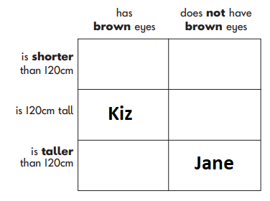
KS1 – 2009 Paper 1
4.
KS1 – 2016 Paper - Reasoning
5.
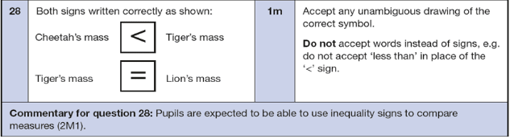
KS1 – 2016 Paper – Reasoning (Second)
6.
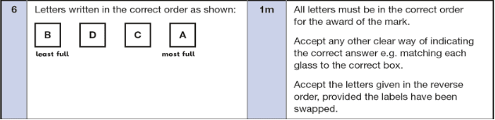
KS1 – 2018 Paper – Reasoning
7.
